Michigan man paralyzed in lake accident undergoes rare stem-cell treatment

By Emily Monacelli on August 22, 2015 at 5:30 AM, updated August 25, 2015 at 1:03 PM

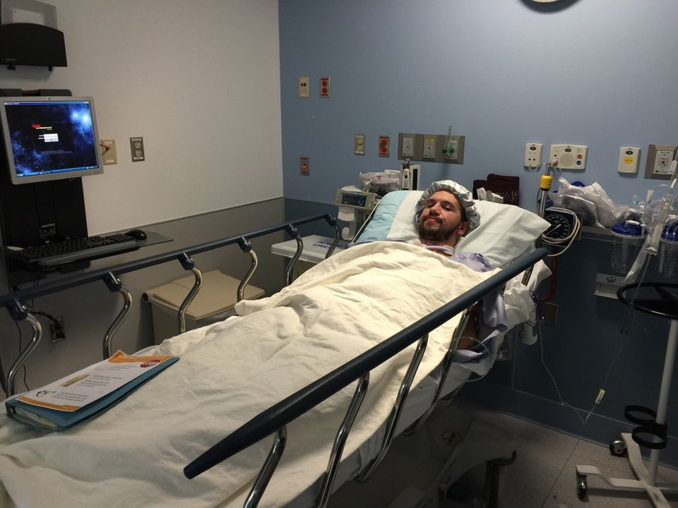

Adam Chaffee is pictured in this courtesy photo following a stem cell procedure. Chaffee has spent the past eight months caring for his disabled brother, who suffered a spinal cord injury in a motorcycle accident. Now Adam will have to rely on help from others after severing his spinal cord in a swimming accident. Photos courtesy of Matthew Chaffee.
Editor's note: This story has been corrected to say that the clinical trial in its first phase, not second.
KALAMAZOO, MI — A Kalamazoo man who became paralyzed in an accident eight months after his brother became paralyzed in a separate accident is participating in a clinical trial that may give him back the use of his arms.
"My hope is that I can use my hands," said Adam Chaffee, 23, who was injured last month after a friend playfully pushed him off a dock. "That's my main hope, my arms and my hands. I can move my arms, and I can move my wrists, but I can't move my fingers."
Chaffee is at Rush University Medical Center in Chicago, where on Thursday he underwent a stem-cell treatment as part of a clinical trial. He fit the bill for ideal candidates: patients ages 18 to 65 who recently experienced a cervical spinal cord injury that caused partial or total paralysis of their arms, legs and torso. The procedure must happen between 14 to 30 days post-injury.
Asterias Biotherapeutics, a San Francisco Bay-area biotechnology company, develops the cells and is sponsoring the study. That means it is free for Chaffee to participate.
"I was super excited. I couldn't believe it when they told me I was eligible for it," Chaffee said in an interview Friday with the Kalamazoo Gazette.
Dr. Richard Fessler, professor of neurosurgery at Rush University Medical Center, said the trial is the first of its kind because it involves injecting stem cells in the neck instead of the thoracic spine, in the upper and middle back. The cells in the neck are much closer together than those further down the spine, Fessler said.
"These cells we know will grow several centimeters, and in the thoracic spine (they) would have to grow much longer in order to have a functional effect," Fessler told the Gazette.
Chaffee's injury is at the fifth level in his neck, which means he has very little use of his hands, Fessler said.
"If I could give him back some use of his hands, it would have a tremendous effect on his quality of life," Fessler said. "That's the goal of this study."
Chaffee became paralyzed on July 26, when a friend playfully pushed him off a dock on Corey Lake near Three Rivers and he hit his head.
The accident left Chaffee, a senior at Western Michigan University, with a complete spinal cord injury with no motor function or sensation below his collarbone.
The accident was a bit of deja vu for Chaffee's family. He had spent the past eight months caring for his brother Matthew, who was paralyzed in a motorcycle accident. Matthew Chaffee's accident left him a paraplegic.
Fessler said a goal of the study is to prove it is safe to inject stem cells in the neck and also that it will have a functional effect on the patient being able to use his arms and hands.
Chaffee had surgery shortly after his accident to stabilize the fracture in his neck. In the procedure, Fessler reopened Chaffee's incision and removed a bone that covers the spinal cord, then opened a membrane that covers the spinal cord and injected the cells into the region of his injury and sewed it back up.
"These particular cells are ones which will grow the coating call myelin," Fessler said. "The theory is in his injury he injured some nerves but didn't completely destroy them. They lost their coating. The goal is to recoat those neurons that are alive but not functioning well to help them function normally."
Chaffee's procedure went well Thursday, and he should be back to Mary Free Bed Rehabilitation Hospital next week, Fessler said.
Fessler said it is unknown if the procedure will help Chaffee regain movement in his hands, since the procedure has never been done in humans.
"I would not expect to see any (results) before six months to a year," Fessler said.
Chaffee is Fessler's second patient and the third in the country to have the procedure done. Two other United States hospitals – one in Atlanta and one in San Jose, Calif. – are participating in the trial. It is a graded trial in its first phase. The first phase allows surgeons to perform the procedures on three patients, then data will be gathered on each patient and sent to a data monitoring committee. The data monitoring committee recommends when the trial can move to the next stage.
Once data is collected, the trial will move to a second, then third round, with higher doses of stem cells given each round. The clinical trial is designed to assess safety and efficacy of escalating doses of the cells to treat spinal cord injuries.
Chaffee said he is staying positive about his future.
"Everyone's been really supportive and caring, and I really appreciate it," Chaffee said. "I'm just trying to stay positive. It's hard to do, but being negative is not going to help anything."

